Session 6: Implementing SQL Triggers
1. Objective
To automate database actions and ensure data integrity within the Project-Hub application using BEFORE and AFTER triggers.

2. Implementation Queries

Step 1: Automatic Timestamp
This trigger ensures that every time a new student is added, their "Created At" time is recorded automatically.
ALTER TABLE Student ADD COLUMN created_at TIMESTAMP DEFAULT CURRENT_TIMESTAMP;

Step 2: Prevent Invalid Data (Task 4)
While the syllabus mentions "salary," for your project, we will prevent "Faculty_Id" from being a negative number to ensure data validity.
DELIMITER //
CREATE TRIGGER PreventNegativeFacultyID
BEFORE INSERT ON Course
FOR EACH ROW
BEGIN
IF NEW.Faculty_Id < 0 THEN
SIGNAL SQLSTATE '45000'
SET MESSAGE_TEXT = 'Error: Faculty ID cannot be negative';
END IF;
END //
DELIMITER ;
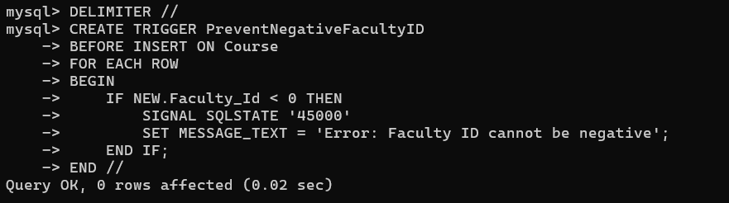

Step 3: Audit Log and Automated Totals (Task 2 & 5)
We will create a table to track project uploads. When a project is added, it will automatically update a "running total" or log the entry.
CREATE TABLE Project_Stats (
Total_Projects INT DEFAULT 0
);
INSERT INTO Project_Stats VALUES (0);
DELIMITER //
CREATE TRIGGER AfterProjectUpload
AFTER INSERT ON Course
FOR EACH ROW
BEGIN
UPDATE Project_Stats SET Total_Projects = Total_Projects + 1;
END //
DELIMITER ;
